OBSERVATION:
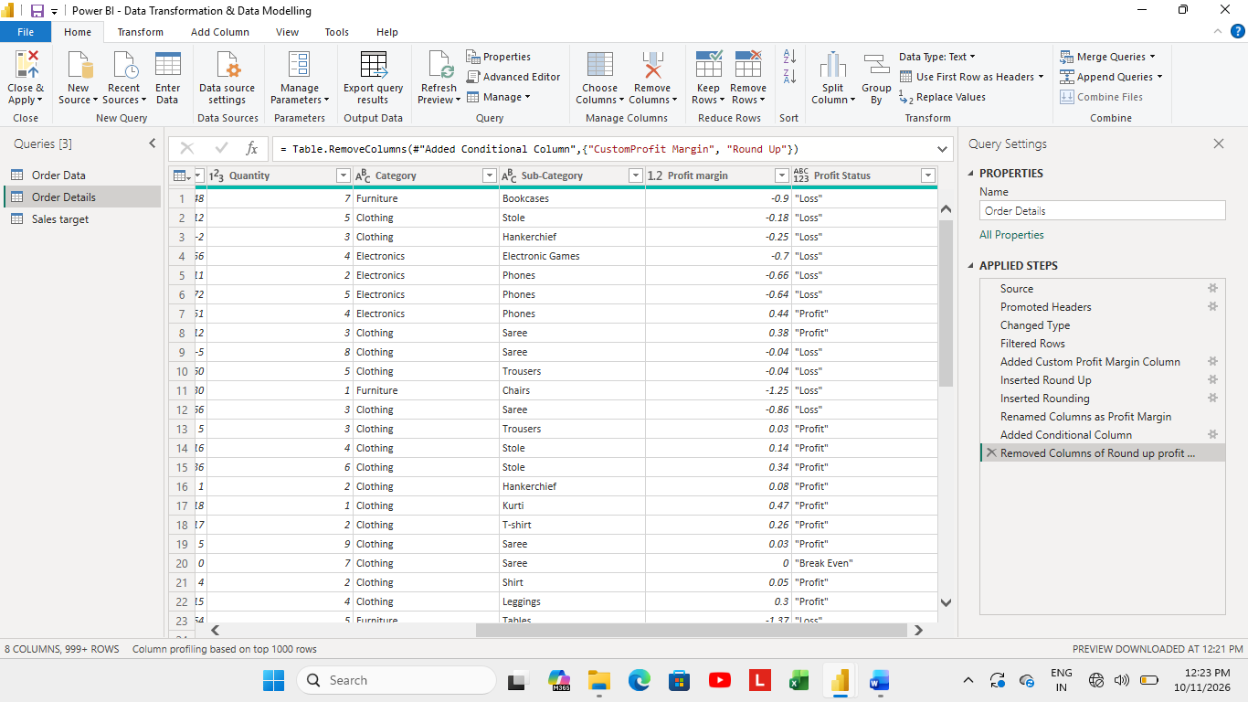
OBSERVATION OF LIST OF ORDER DETAILS TABLE:
- Kept first 500 rows.
- Used proper function by Capitalising each word.
- Merged state and city columns, Renamed as Location.

OBSERVATION OF ORDER DETAILS TABLE:
- I added profit margin column as the percentage of Profit divided by amount used round function to minimise decimal values.
- And also added conditional column named profit status.
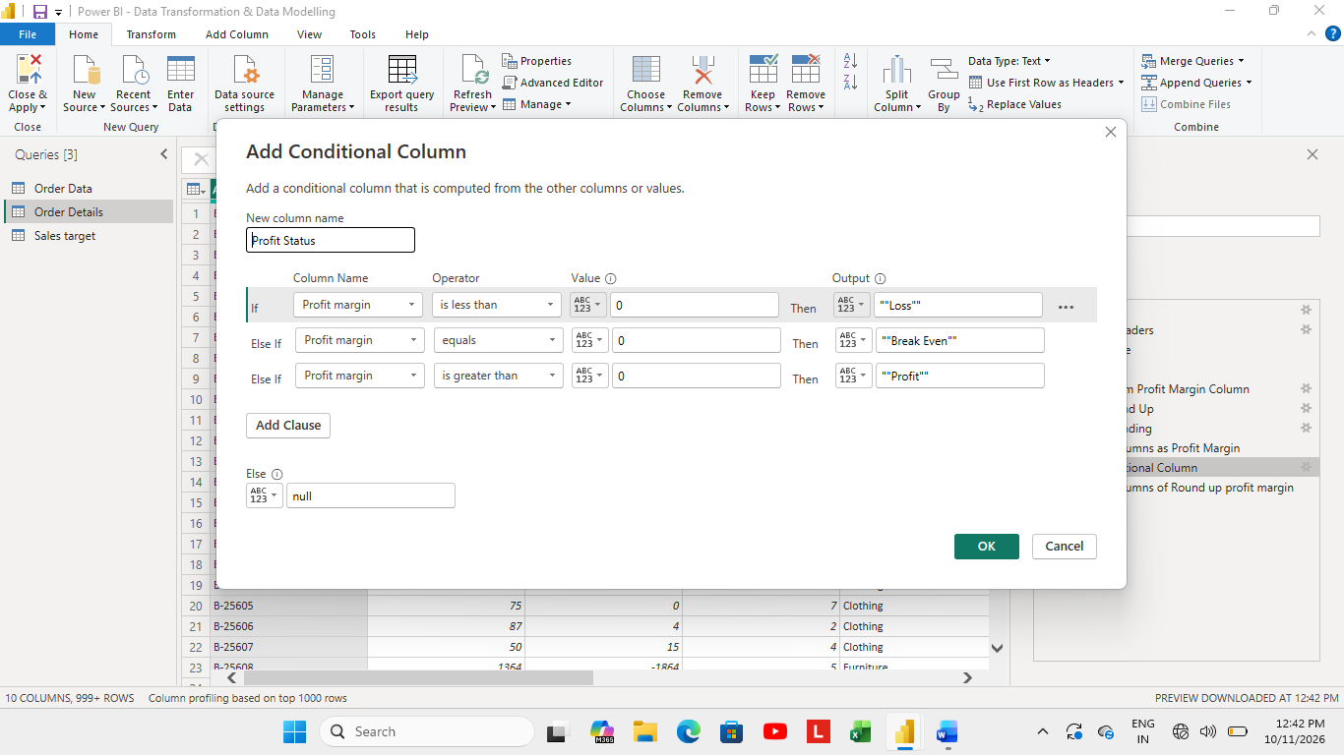
- Now after adding new columns, I merged both the tables and names as “Order Data” based on the “Order Id” relationship.
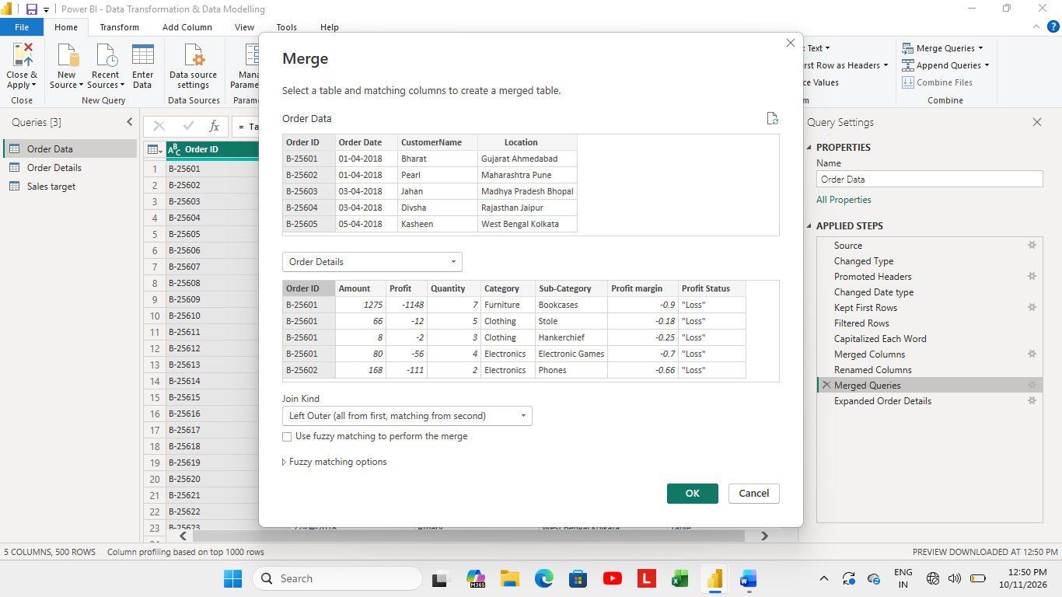
- After merging tables I didn’t find any missing data or duplicate rows.
- Used sorting in “Order Date” column and filtered the “Location” column by” Tamil Nadu state” wise of Order Data table.
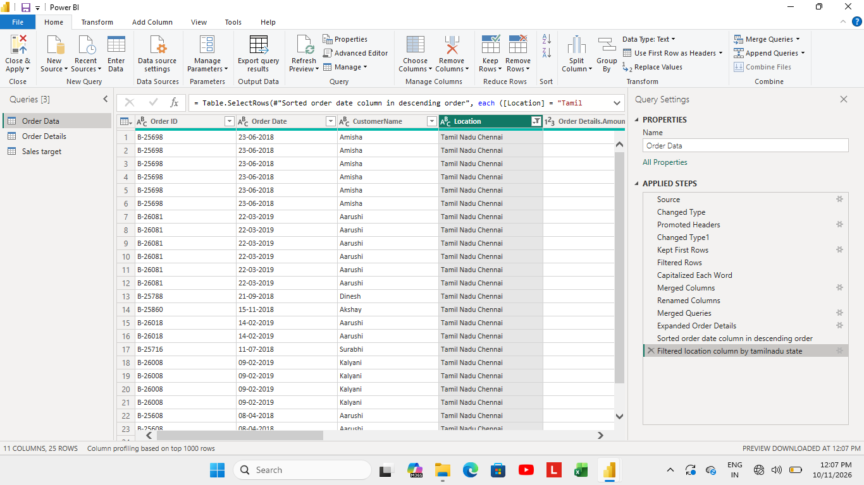
- Calculated the count of each order id(B-25710) in “order details” table.
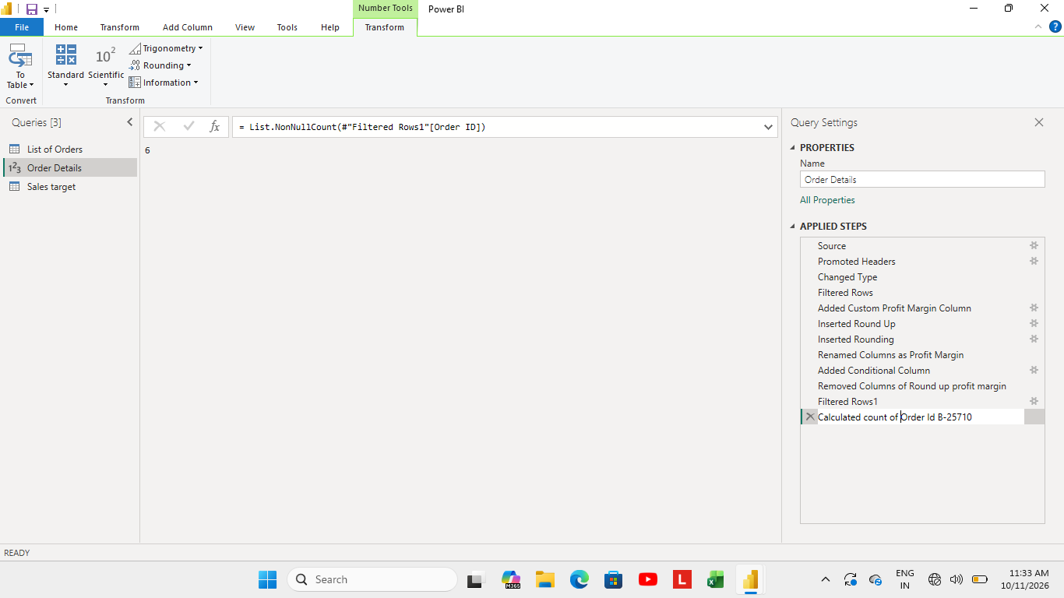
- Calculated average profit of Electronics by category wise.
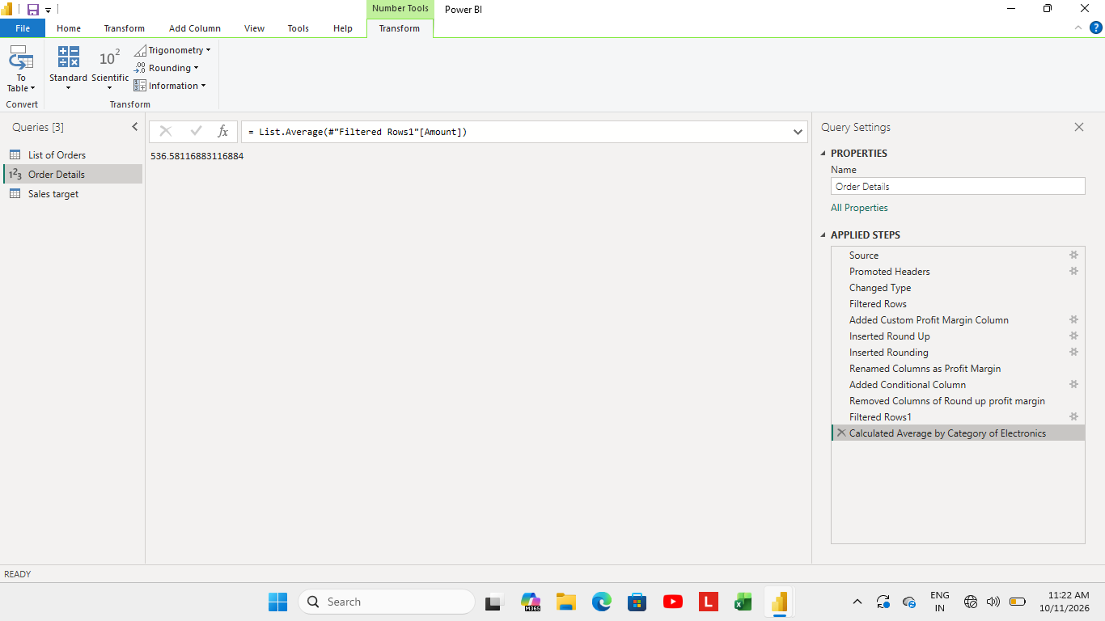
- In Sales Target table aggregated the total target amount by month of order date for February.
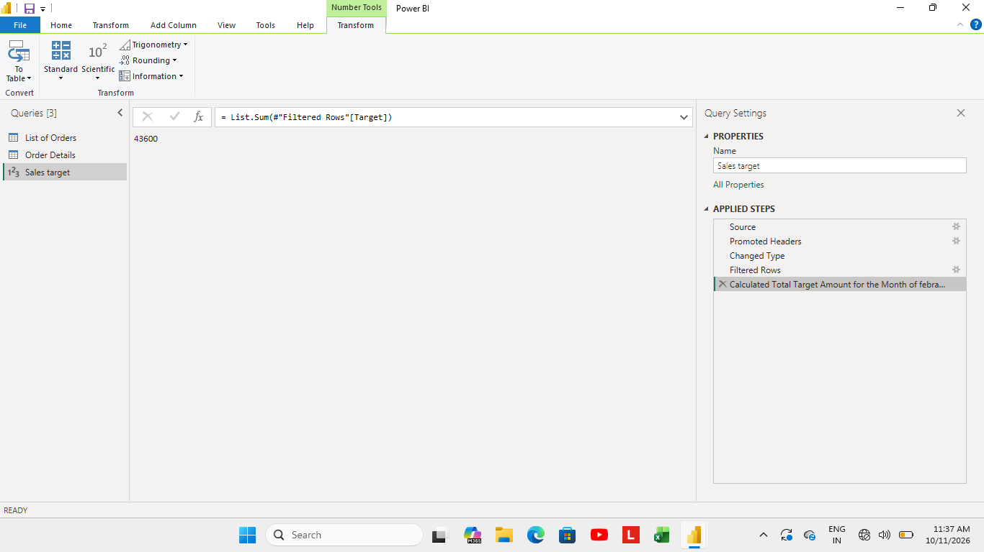
- Established the relationship between “List of Order” and “Order Details” table using “Column Id” column.
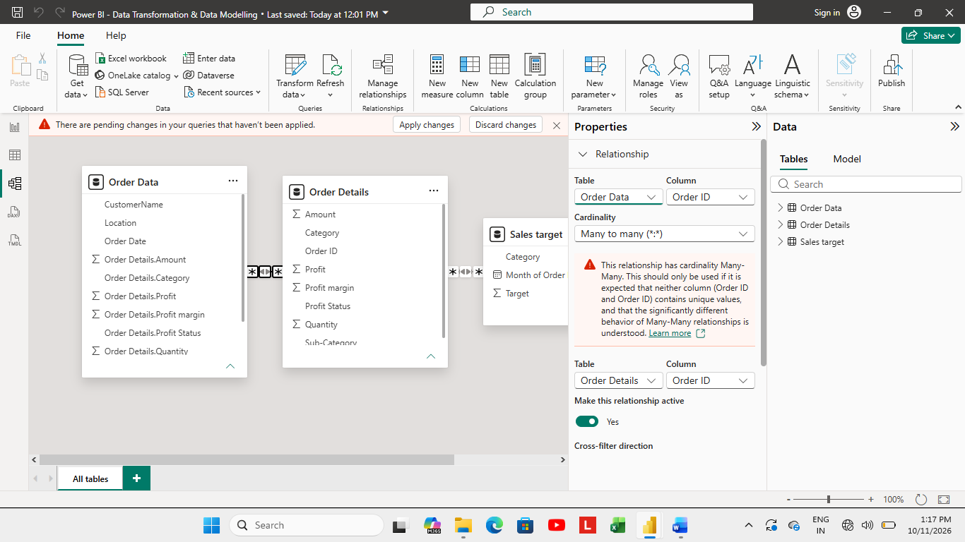
- Built a relationship between “Order Details” and “Sales Target” table based on “Category” column.
